HYPERALLERGIC

Best of 2016: OurTop15 Exhibitions Across the United States

Here’s a small taste of what this vast country had to offer in art this year.
This year, Hyperallergic writers and editors combed Philadelphia, Denver, Miami, Pittsburgh, and many other US cities to get a taste for what the country had to offer in its museums, galleries, and performance spaces. We found a number of retrospectives that revealed surprising or unexplored aspects of familiar artists, as well as surveys that revised art history as we know it. And, of course, there were the exhibitions timed for the election that in hindsight seemed to already know we were headed for doom.

6. Kay WalkingStick: An American Artist at the National Museum of the American Indian (Washington, DC)
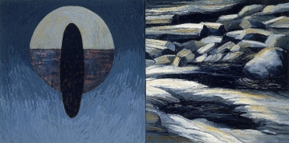
Kay WalkingStick, “Night/ᎤᎡᎢ (Usvi)” (1991), oil, acrylic, wax, and copper on canvas, 36.25 x 72.25 x 2 in (courtesy the Montclair Art Museum, purchased with funds provided by Alberta Stout)
November 7, 2015–September 18, 2016
It’s incredible that this exhibition was the 81-year-old’s first retrospective, but thankfully it was quite excellent — though don’t get me started on the fact that an important contemporary artist of Cherokee descent is being given a retrospective in a museum better known for anthropological and historical displays. WalkingStick’s show easily glides between different disparate bodies of work, revealing an intense passion for painting in the 1970s, an interest in diptychs and duality in the ’80s and ’90s, and she continues to push herself until today. At the core of her work is the idea of landscape as something that doesn’t simply appear like a photograph, with its seemingly objective gaze, but a relationship that unearths personal histories, archetypes, and stereotypes. Her art, like so much great art, seems to resist the notion of artistic evolution, as if we could forget the strands that we leave untied. Again and again she demonstrates that the act of creation is part of a continuing relationship and not only marked by a beginning and an end. —Hrag Vartanian

